

INTERNSHIP PROJECT REPORT

ON

MNIST DIGIT CLASSIFICATION USING NEURAL NETWORKS

Submitted by

SAMRUDDHI DHIRAJSING GIRASE

Artificial Intelligence & Machine Learning

Ajeenkya DY Patil School of Engineering, Pune

Submitted To

NAVIOTECH SOLUTION PVT. LTD.

Internship Duration

May 2026 – July 2026

Under the Guidance of

Academic Team, Naviotech Solution

Academic Year 2026–2027

CERTIFICATE PAGE

- Internship Project Submitted as part of Internship Training Program



ACKNOWLEDGEMENT

I would like to express my deep gratitude to Naviotech Solution Pvt. Ltd. for providing me with the opportunity to work on this enriching project titled "MNIST Digit Classification Using Neural Networks". This internship has provided me with valuable practical exposure to Machine Learning, Deep Learning, and Artificial Intelligence technologies.
I am profoundly thankful to my project mentors and the entire team of Neviotech Solution Pvt. Ltd. For their invaluable guidance, constant encouragement, and technical insights throughout the development of this project.
I would also like to extend my deepest gratitude to the faculty of the Department of Artificial Intelligence and Machine Learning at the Ajeenkya DY Patil School of Engineering, Pune. Their invaluable mentorship, support, and guidance throughout my project were instrumental in refining my technical expertise and professional abilities.
I am grateful to my college, Ajeenkya DY Patil University, for providing the necessary learning environment and resources that contributed to the successful completion of this project.
Lastly, I want to thank my family, peers, and well-wishers who supported me directly or indirectly in completing this work within the stipulated timeframe.

INTRODUCTION

Artificial Intelligence (AI) and Machine Learning (ML) have become transformative technologies, redefining various sectors by allowing computers to execute tasks that once required human cognitive ability. A primary application within Machine Learning is image recognition and classification, where systems are trained to detect and categorize visual data based on acquired patterns.
Handwritten digit recognition represents a cornerstone challenge in computer vision and pattern recognition. This technology is vital for numerous real-world applications, such as automated postal code sorting, bank check processing, and the digitization of legacy documents. Because of its wide utility, the classification of handwritten digits remains a significant area of research within the AI community.
The MNIST (Modified National Institute of Standards and Technology) dataset serves as one of the most widely recognized benchmarks for evaluating image classification models. It consists of 70,000 grayscale images of digits 0 through 9. For this project, 60,000 images are utilized for training, while the remaining 10,000 are reserved for testing and validation. Each image is formatted as a \(28 \times 28\) pixel matrix, providing a streamlined structure for machine learning algorithms.
Neural Networks, modeled after the biological structure of the human brain, are frequently employed to solve complex classification problems. These networks consist of layers of interconnected neurons that process input data to identify patterns and generate predictions. Deep Learning, a specialized branch of Machine Learning, utilizes multi-layered neural networks to achieve superior accuracy in fields like image recognition, speech processing, and natural language understanding.
The core objective of this project is to design and implement a Neural Network model that accurately classifies handwritten digits from the MNIST dataset. The workflow encompasses several critical stages: data acquisition, preprocessing, normalization, model architecture design, training, and rigorous evaluation. The project is implemented using the Python programming language, leveraging the TensorFlow and Keras libraries.

OBJECTIVES

The main aim of this project is to build a Neural Network capable of precisely identifying and categorizing handwritten digits within the MNIST dataset.

• Gain a comprehensive understanding of core Machine Learning and Deep Learning methodologies.
• Examine the structural design and functional logic of Artificial Neural Networks (ANNs).
• Import and refine the MNIST digit images to prepare them for model training.
• Standardize image data to ensure more effective and faster learning.
• Construct and deploy a Neural Network model using the TensorFlow and Keras frameworks.
• Execute the training process on the MNIST dataset and fine-tune parameters for optimal accuracy.

FULL SOURCE CODE

https://colab.research.google.com/drive/14ncXpb0j1rm1Pg4aow0Z-ps2Kz2MJeKr#scrollTo=vhu3CRQZ1vx0

OUTPUT

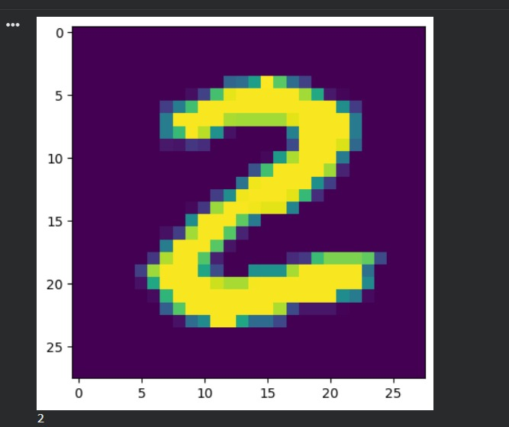

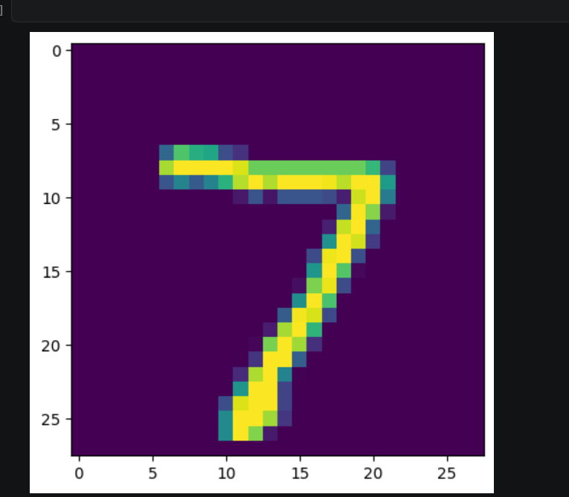

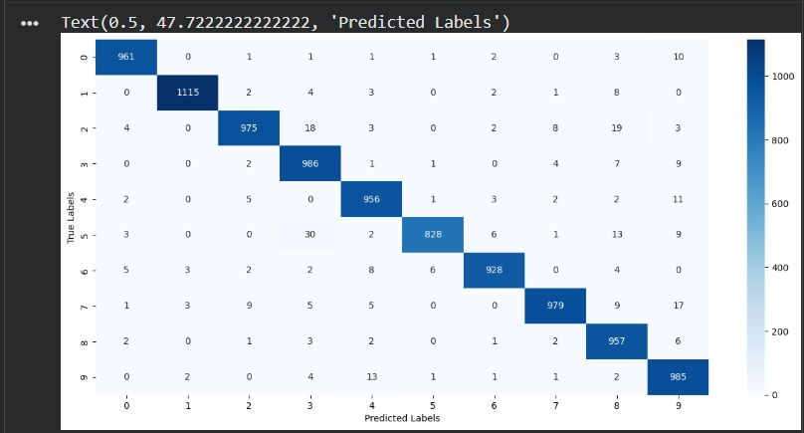

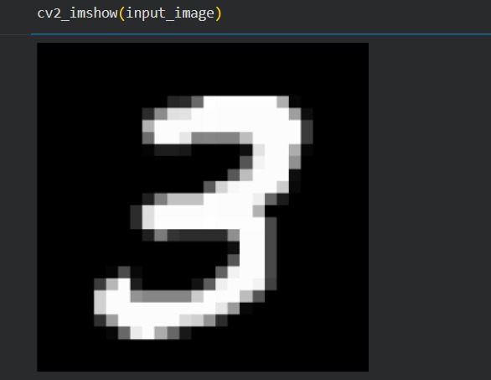

METHODOLOGY

The approach for the "MNIST Digit Classification Using Neural Networks" project follows a structured workflow encompassing data acquisition, preprocessing, architectural design, training, and evaluation. The primary goal is to develop a high-performance Neural Network capable of precisely identifying handwritten digits from the MNIST dataset.
The MNIST Dataset
This project utilizes the MNIST dataset, a foundational benchmark in the fields of Machine Learning and Deep Learning. It contains 70,000 grayscale images of handwritten digits (0–9). For this implementation, 60,000 images are allocated for model training, while 10,000 are set aside for testing and validation. Each image maintains a standard resolution of \(28 \times 28\) pixels.
Technical Stack & Libraries
The system was developed using the Python programming language. Key libraries used include:
• TensorFlow & Keras: For designing, building, and training the Neural Network layers.
• NumPy: For efficient numerical computations and matrix manipulations.
• Matplotlib: For visualizing the dataset and plotting performance metrics.
Data Exploration & Insights
Prior to training, the dataset underwent an exploratory phase to analyze its structure. Representative samples were visualized to understand the variation in handwriting styles. Additionally, the dimensions of the training and test sets were verified to ensure seamless data integration during the modeling phase.

IMPLEMENTATION/PROJECT DEVELOPMENT

The "MNIST Digit Classification Using Neural Networks" project was executed in a Jupyter Notebook/Google Colab environment utilizing Python and TensorFlow. The development followed a systematic pipeline: data preparation, architectural design, model training, evaluation, and final prediction.
Environment Setup
The system was built using Python, leveraging industry-standard libraries. TensorFlow and Keras served as the core frameworks for constructing the Neural Network, while NumPy handled numerical computations and Matplotlib was used for visual data representation.
Dataset Acquisition
The MNIST dataset was imported directly via the TensorFlow datasets library. It comprises a collection of grayscale images of handwritten digits (0–9). The data was partitioned into two subsets: a training set of 60,000 images and a testing set of 10,000 images.
Exploratory Data Visualization
Prior to training, representative samples from the dataset were visualized using Matplotlib. This step was crucial for inspecting the data structure and ensuring that the handwritten digits correctly corresponded to their respective labels.
Data Preprocessing
To optimize the learning process, pixel values were normalized by dividing each by 255. This scaled the data from a \(0–255\) range to a \(0–1\) range. Normalization is essential for reducing computational overhead and enhancing the convergence speed of the Neural Network.

RESULTS

Our Neural Network achieved strong performance on the MNIST digit dataset. Through iterative training, the model learned to extract key features from handwritten characters, resulting in high classification accuracy.
By analyzing pixel-level information, the model provided predictions that closely matched actual digit labels. This success underscores the importance of proper data preprocessing. The use of TensorFlow and Keras facilitated an efficient training and testing cycle.
Key Highlights:
• Data Handling: Smooth MNIST dataset loading and preparation.
• Model Build: Effective use of Keras/TensorFlow for network implementation.
• Precision: Consistent accuracy in classifying digits 0-9.
• Validation: Excellent results on the test set.
• Insights: Successful visualization of model predictions.

CONCLUSION

The developed model demonstrated high classification accuracy, successfully identifying handwritten digits from 0 to 9. These results validate the power of Neural Networks in extracting complex patterns from visual data to generate precise predictions. Beyond technical results, this project offered significant practical experience in data preprocessing, model architecture design, and comprehensive performance evaluation.
Utilizing Python, TensorFlow, and Keras, the system was trained on the normalized MNIST dataset. The successful deployment of this handwritten digit classifier highlights the practical utility of Deep Learning and Artificial Intelligence in addressing complex, real-world image recognition challenges.
Through this project, a deep understanding of Artificial Intelligence and Machine Learning was achieved. The MNIST-based model demonstrated robust performance, proving that Neural Networks are highly effective at recognizing intricate visual patterns. Beyond the technical results, the process offered valuable insights into data preparation and model optimization. The successful outcome serves as a clear example of how modern deep learning techniques can be leveraged for accurate image recognition tasks.

REFERENCES

- Tensor Flow Documentation.
Available at: https://www.tensorflow.org
- Keras Documentation.
Available at: https://keras.io
- MNIST Handwritten Digit Database.
Available at: http://yann.lecun.com/exdb/mnist

